**Homework 5**

1. A flat plate coated with a volatile organic compound (VOC) is exposed to a parallel flow of atmospheric air at 20oC, with a free stream velocity (i.e., upstream uniform velocity) of 5 m/s. The length of the flat plate in the direction of the flow is 0.5 m. The saturation concentration of the VOC in air at these conditions is 1.85 x 10-9 mol/cm3, and its diffusivity in air under these conditions is 0.068 cm2/s. The density of the VOC is 1.21 g/cm3 and its molecular weight is 140.2 g/mol. Assume the viscosity of the air under these conditions to be 0.155 cm2/s. Determine **(A)** the mass transfer coefficient, $k_{m}$ for this system, and **(B)** the time it would take for the average thickness of the VOC layer to decrease by 1 mm under these conditions. (Hint: though the system deals with diffusion of a solute through a gas instead of a liquid, the solution is similar. Be sure to select the correct equation that models this system.) ***(Ans: $k_{m}=0.464\frac{cm}{s}; t=11.63 days$)***
2. A spherical protein with a MW of 15,000 Da in an aqueous solution ( $μ$ = 1 cP, = 1 g/cm3) is being filtered at 20oC through a microporous membrane within a 25 mm diameter stirred ultrafiltration cell. The membrane has nominal molecular weight cutoff (NMWCO) of 30,000 Da. The stirring speed is 1000 RPM. The filtration flux (i.e., $q$) through the membrane is equal to 1.5 x 10-3 cm/s. For a stirred ultrafiltration cell, the following equation can be used to calculate the Sherwood number:

$$Sh=\frac{k_{m}r_{cell}}{D}=0.23Re^{0.567}Sc^{0.33}=0.23{\left(\frac{ρωr_{cell}^{2}}{μ}\right)}^{0.567}{\left(\frac{μ}{ρD}\right)}^{0.33}$$

where $r_{cell}$ is the radius of the stirred ultrafiltration cell, and $ω$ is the stirring speed (in radians per second). Determine **(A)** the mass transfer coefficient ($k_{m}$) and **(B)** the observed sieving coefficient ($S_{o}$) for the membrane. **(Ans: $k_{m}=1.056×10^{-3}\frac{cm}{s}, S_{o}=0.152$)**

1. Consider a slab layer of cells being grown between two microporous support membranes. The half-thickness of the cell layer is 125 mm and the cell volume fraction is 0.10. The permeability of oxygen through the support membrane is estimated to be equal to 1.5 x 10-3 cm/s. The cell-membrane system is immersed in a well-mixed nutrient medium maintained at pO2 = 150 mmHg. An oxygen microelectrode placed at the centerline of the layer of cells gives a pO2 reading of 15 mmHg. Assume the diffusivity of oxygen through the cell layer is 2.4 x 10-5 cm2/s. Assume that Henry’s constant for oxygen under these conditions is 0.74 mmHg/mM. Determine the reaction rate at which these cells are consuming oxygen (report your answer in mM/s). (Hint: since the solution outside the membrane is well mixed, you will not need to include the mass transfer effects of oxygen to the membrane; you only need to consider the diffusion through the membrane.)

**(Ans: $Γ=157.4\frac{μM}{s}$)**

1. A pharmacokinetic study of a particular drug taken orally as a single dose provided an AUC of 1085.5 ng hr/mL, a Cmax equal to 98.5 ng/mL, and a tmax of 2.1 hr. The drug dose was 80 mg and the drug does not bind to proteins (i.e., *f* = 1). From the given data, determine **(A)** the apparent volume, **(B)** the elimination rate constant ($k_{te}$), and **(C)** the absorption rate constant ($k_{a}$). Plot the concentration profile over a 24-hr period. **(Ans: $k_{te}=1.248 hr^{-1};k_{a}=0.116 hr^{-1}$)**
2. The data shown in the table below represents plasma inulin concentrations following a rapid IV injection of 4.5 g of inulin in an 80 kg human. Determine **(A)** the pharmacokinetic parameters of a two-compartment model between plasma and tissue (i.e., $V_{plasma}, k_{tp}, k_{te}, k_{pt}, \text{and} V_{tissue}$), and **(B)** determine the GFR from these values. **(C)** Provide a plot with the data points (just points) from the table and the best fit line generated using your parameters (no markers, just the line); your plot will look similar to the one below. **(Ans: $k_{tp}=0.030251 m{in}^{-1}$; $V_{plasma}=6.861 L$; $GFR=243.9\frac{mL}{min}$)**

|  |  |
| --- | --- |
| **Time, min** | **Plasma Inulin Concentration, mg/mL** |
| 10 | 440 |
| 20 | 320 |
| 40 | 200 |
| 60 | 150 |
| 90 | 110 |
| 120 | 80 |
| 150 | 60 |
| 175 | 48 |
| 210 | 35 |
| 240 | 25 |

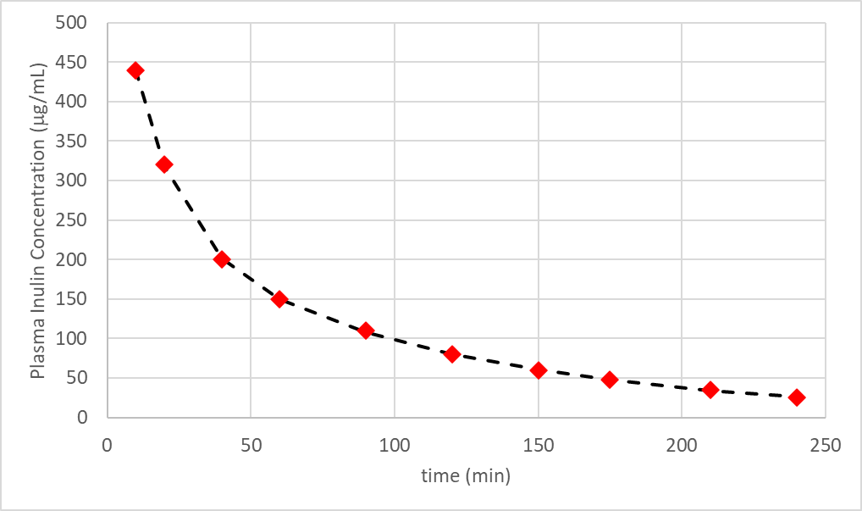

*Hint for #5:*

*Enter the given data in Excel. Designate a block of cells that will contain your guess values for the different parameters that you are trying to find. In the column next to the concentration data, write out the equation (the one that is appropriate for this type of system) using the parameter guess values and the time from the table (be careful how you “fix $$” the cells).*

*In the next column over (right of the concentration values from your equation) take the difference between the data and model concentrations and square this difference (this is to make all negative values positive). At the bottom of this column, compute the sum of the squares of the differences.*

*Under the data tab in Excel, click on Solver (usually located on the far right). If you don’t see it, go to FILE >> OPTIONS >> ADD-INS. Click on Solver Add-in and click on GO; check the box for Solver Add-in and press OK. The solver should show up.*

*Your objective cell is the sum of the squares of the difference. Ideally this should be 0, but since all the terms above it will be positive, then the minimum value is also 0 (it is highly unlikely that the Excel Solver will be able to hit 0, so a small minimum will work). For cells that you want to change, highlight the cells with the parameters with your guess values (don’t highlight cells that have built-in formulas that you typed). You may need to run the solver 2 or 3 times to confirm that it reached a valid solution. (Hint: use initial guesses that are around the same order of magnitude from the examples in class and in your textbook).*

*Check your plot of the data and model results to see if the line closely follows the data. Check your units too (Excel does not recognize units, so you might need to type in any conversions that are needed).*

*Your numbers may not match the provided answers exactly (that’s okay). Use the graph to check to see if the model follows the data well.*